LAB 1: Measuring the V-I Characteristics

of a Diode

**Date: Reg.#**

## OBJECTIVES:

## To experimentally measure the V-I characteristics of a diode and generate its plot.

## SUGGESTED READING:

* + [Chapter 2: “p-n diodes”, *introductory Electronic Devices and Circuits by Paynter.*](http://arduino.cc/en/Guide/HomePage)
* Datasheet : 1N4007 Diode
* <https://learn.sparkfun.com/tutorials/diodes/real-diode-characteristics>
* <http://www.electronics-tutorials.ws/diode/diode_3.html>

Please read through all the suggested reading before you come to the lab.

## EQUIPMENT AND COMPONENTS:

* Basic Circuits Training Board
* 1N4007 Diode
* Jumper Wires
* Scope / DMM

---------------------------------------------------------------------------------------------------------------------

**P-N Junction Diode:**

A Diode is a semi-conductor device created by combining a p-type semiconductor material with an n-type semiconductor material. This results in the formation of a p-n junction (Fig 1.1).

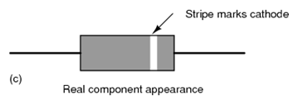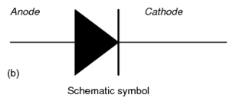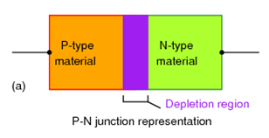

***Fig 1.1: Diode representation***

A diode can be used in two modes:

* Forward bias
* Reverse bias

Essentially, a diode acts as a one-way switch. It allows the flow of current in only one direction.

**Forward Bias State:**

When the p-type material is at a greater potential with respect to the n-type material, the diode is said to be in a forward bias state. In forward bias state, a diode acts as a short-circuit and allows the flow of current. Ideally, no voltage is dropped across the diode and it offers zero resistance to current flow. The width of the depletion region effectively decreases to zero in forward bias state.

**Reverse Bias State:**

When the p-type material is at an equal or lower potential than the n-type material, the diode is said to be in reverse bias state. In a reverse bias state, the diode acts as an open circuit and ideally does not allow any current flow through it.

# The V-I curve of a Diode:

Fig 1.2 describes how the current through a diode varies with respect to a change in its applied voltage.

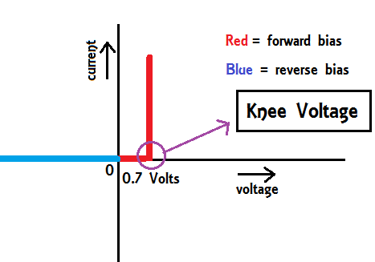

***Fig 1.2: V-I characteristics of an ideal diode, considering only forward voltage drop***

The ‘Knee Voltage’ is the point where the junction barrier potential is overcome almost completely, and electrons begin to flow rapidly. It can vary from 0.7V to 1.5V in a real silicon diode, and from 0.3V to 0.6V in a Ge based diode. However, a real diode will not exhibit the same V-I characteristics, as we will find out during this experiment. This experiment will help you understand the characteristics of a real diode much better.

# Procedure:

* Connect the diode to the variable power supply of the basic circuit trainer board in the following configuration:
* Increase the voltage from the variable voltage supply by a small step and measure the current through the diode using the scope’s DMM function/DMM.
* The input voltage can be measured by connecting the voltmeter between the two green spots (i.e. in parallel with the source), and the current can be measured by connecting the ammeter between the two blue spots (i.e. in series with the diode).
* Repeat the process and record the values of voltage and current.
* Similarly, connect the diode in the reverse bias configuration, and record the values of applied voltage and current in the reverse bias state.
* The reverse bias voltage can be applied up to 30 V (the maximum voltage the trainer variable supply can give).
* Display the readings in the form of a table below:

**MATLAB Simulation:**

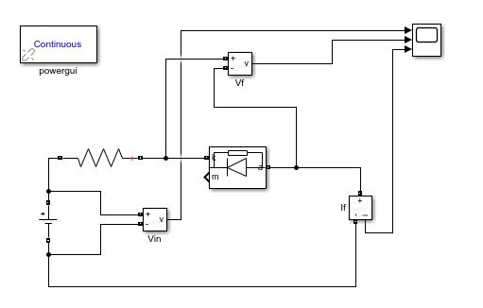

Reverse Bias

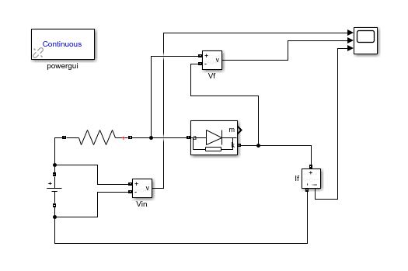

Forward Bias

|  |  |
| --- | --- |
| **Voltage Applied (volts)** | **Reverse Current (micro amperes)** |
| 0.6 | 0.13 |
| 0.8 | 0.151 |
| 1.0 | 0.171 |
| 1.2 | 0.191 |
| **Voltage Applied (volts)** | **Forward Current (milli amperes)** |
| 0.6 | 0 |
| 0.8 | 0.099 |
| 1.0 | 0.299 |
| 1.2 | 0.499 |
| 1.4 | 0.699 |

**Hardware Results:**

|  |  |
| --- | --- |
| **Voltage Applied (volts)** | **Reverse Current (micro amperes)** |
| 6 |  |
| 12 |  |
| 18 |  |
| 24 |  |
| **Voltage Applied (volts)** | **Forward Current (milli amperes)** |
| 1 | 0.01 |
| 2 | 0.03 |
| 3 | 0.05 |
| 4 | 0.08 |
| 5 | 0.11 |

## V-I Curve:

A V-I curve shows the relation between the current passing through a device and the applied input voltage to it. Use **Microsoft Excel** to plot the data you collected in the form of a V-I curve and attach it below:

REVERSE BIAS

FORWARD BIAS

# REVIEW QUESTIONS:

Q: How does the V-I curve of a practical diode differ from the V-I curve of an ideal diode?

Q: Write any three applications of a practical diode.

Q:What would happen if you used an LED instead of a simple diode? Would the graph be any different?

What would happen if an AC source was used instead of a DC voltage with the LED?

**COMMENTS:**

P.S: Comments are logical observations and findings that you learned during practice.